

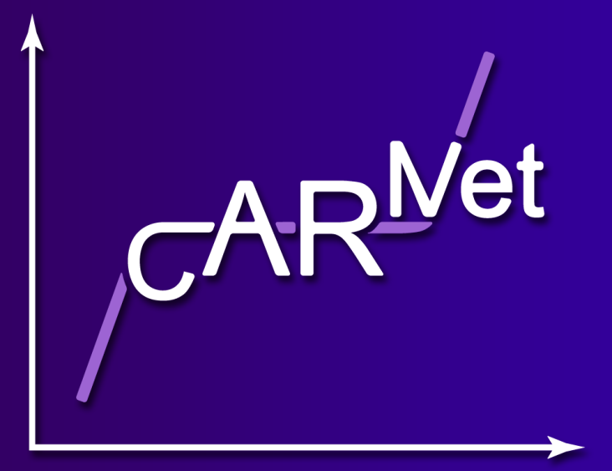

# *The 5th International Meeting on Cerebral Haemodynamic Regulation (CARNet)*

# Monday 13th July 2015, Chilworth Manor Hotel, Southampton

***PROVISIONAL PROGRAMME***

|  |  |
| --- | --- |
| 08:50 – 09:00 | **Welcome** D M Simpson, University of Southampton, UK |
|  | ***Physiology 1*** |
| 09:00 – 09:40 | **Neural control of the cerebral circulation** Invited Speaker: E Hamel, McGill University, Montreal, Canada |
| 09:40 – 10:00 | **Cerebral blood flow changes in response to mild hypovoleemia and positive pressure ventilation** M Skytioti, University of Oslo, Norway |
| 10:00 – 10:20 | **Comparison between wavelet phaseshift and pressure reactivity index in determination of optimal cerebral perfusion pressure** X Liu, University of Cambridge, UK |
| 10:20 – 10:40 | **Summary presentation of ‘Science Labs’** C Haubrich, University Hospital Aachen, Germany |
| 10:40 – 11:10 | **Break & Exhibition & Set-up for posters** |
|  | ***Measurement and Modelling 1*** |
| 11:10 – 11:50 | **Individualised-patient modelling for in-silico interpretation and prediction of cerebral tissue physiology and pathophysiology** Invited Speaker: I Tachtsidis, University College London, UK |
| 11:50 – 12:10 | **Assessment of dynamic cerebral autoregulation without blood pressure measurement** J L Jara, University of Santiago de Chile, Chile |
| 12:10 – 12:30 | **The effect of random step-wise lower-body negative pressure on cardio and cerebrovascular measures** D Nikolic, University of Southampton, UK |
| 12:30 – 12:50 | **Posters – 2 minute summary for posters** |
| 12:50 – 14:00 | **Lunch & Exhibition & Posters** |
|  | ***Clinical 1*** |
| 14:00 – 14:40 | **Lymphatic drainage of the brain and pathogenesis of Alzheimer’s disease** Invited Speaker: R Carare, University of Southampton, UK |
| 14:40 – 15:00 | **Dynamic cerebral autoregulation is impaired in idiopathic Parkinson's disease** V Haunton, University of Leicester, UK |
| 15:00 – 15:20 | **Dynamic cerebral autoregulation impairment in stroke patients with coexistent large artery and small vessel disease** G Tian, Chinese University of Hong Kong, China |
| 15:20 – 15:40 | **Posters – 2 minute summary for posters** |
| 15:40 – 16:10 | **Break & Exhibition & Posters** |
|  | ***Measurement and Modelling 2*** |
| 16:10 – 16:20 | **Concensus on TFA analysis – short presentation** J Claassen |
| 16:20 – 16:40 | **Pseudorandom steps in lower body negative pressure can improve the repeatability in the assessment of cerebral autoregulation** D M Simpson, University of Southampton, UK |
| 16:40 – 17:00 | **Contribution of identifyability techniques to cerebral autoregulation** A Mahdi, University of Oxford, UK |
| 17:00 - 17:10 | **Posters – 2 minute summary for posters** |
| 17:10 – 17:30 | **CARNet bootstrap project: summary of first results** J W Elting, University Medical Centre Groningen, Netherlands |
| 17:30 – 18:00 | **Break & Exhibition & Posters** |
| 18:00 – 19:00 | **CARNet AGM** |
| 19:00 – 19:30 | **Break** |
| 19:30 | **Dinner at Chilworth Manor** |





# *The 5th International Meeting on Cerebral Haemodynamic Regulation (CARNet)*

# Tuesday 14th July 2015, Chilworth Manor Hotel, Southampton

***PROVISIONAL PROGRAMME***

|  |  |
| --- | --- |
|  | ***Clinical 2*** |
| 09:00 – 09:40 | **The brain controls physical exercise, but is also challenged by it** Invited Speaker: J J van Lieshout, University of Amsterdam, The Netherlands |
| 09:40 – 10:00 | **Cerebral autoregulation in different hypertensive disorders of pregnancy** T van Veen, University Medical Center Groningen, The Netherlands |
| 10:00 – 10:20 | **Cerebrovascular autoregulation during and after surgical ligation of the ductus arteriosus using two surgical approaches in preterm infants** JW Elting, University Medical Center Groningen, The Netherlands |
| 10:20 – 10:40 | **Is this autoregulation?** M Czosnyka, University of Cambridge, UK |
| 10:40 – 11:10 | **Break & Exhibition & Posters** |
|  | ***Measurement and Modelling 3*** |
| 11:10 – 11:50 | **Managing an integrated database and large-scale collaboration: the pain and the pleasure** Invited Speaker: I Piper, South Glasgow University Hospital, Glasgow, UK |
| 11:50 – 12:10 | **Reduced dynamic cerebral vasomotor reactivity in patients with mild cognitive impairment** V Marmarelis, University of Southern California, Los Angeles, USA |
| 12:10 – 12:30 | **Model-assisted assessment of effects of age and hypertension on cerebral blood flow velocity**  G.Mader, North Carolina State University, USA |
| 12:30 – 12:50 | **The time-dependent variability of arterial CO2 influences the nonstationary properties of dynamic CO2 reactivity estimates during resting conditions** G. Mitsis, McGill University, Montreal, Canada |
| 12:50 – 14:00 | **Lunch & Exhibition & Posters** |
|  | ***Physiology 2*** |
| 14:00 – 14:40 | **Blood pressure trials in acute stroke: an exercise in futility? - what is the role of other haemodynamic parameters?** Invited Speaker: T Robinson, University of Leicester, UK |
| 14:40 – 15:00 | **Comparison of cerebral tissue oxygenation with cerebral arterial flow velocity responses to spontaneous changes in blood CO2 and pressure in older adults**  V Marmarelis, University of Southern California, Los Angeles, USA |
| 15:00 – 15:20 | **Effects of ageing, and measurement method, on gross and cortical cerebral autoregulatory upper limits**  E Thompson, University of Birmingham, UK |
| 15:20 – 15:40 | **Aging is associated with maintained cerebral autoregulation despite impaired cerebrovascular dilatory response to carbon dioxide** J Serrador, Rutgers Biomedical Health Sciences, Newark, NJ, USA |
| 15:40 – 16:10 | **Break & Posters** |
|  | ***Clinical 3*** |
| 16:10 – 16:30 | **Cerebral Autoregulation after cardiac surgery: a prospective study** RC Nogueira, University of Sao Paulo. Brazil |
| 16:30 – 16:50 | **Autoregulation-based optimal cerebral perfusion pressure in a prospective traumatic brain injury cohort** J Donnelly, University of Cambridge, UK |
| 16:50 – 17:10 | **Relationship between cerebrovascular pressure reactivity and intracranial hypertension in traumatic brain injury**  M Czosnyka, University of Cambridge, UK |
| 17:10 – 17:30 | **Association of the outcome of traumatic brain injury patients with cerebrovascular autoregulation impairment events**  V Petkus, Kaunas University of Technology, Lithuania |
| 17:30 – 17:45 | **Break & remove posters** |
| 17:45 – 18:45 | **Tutorial / Clinic** J Serrador, Rutgers Biomedical Health Sciences, Newark, NJ, USA |
| 19:15 | **Conference Dinner** |





# *The 5th International Meeting on Cerebral Haemodynamic Regulation (CARNet)*

# Wednesday 15th July 2015, Chilworth Manor Hotel, Southampton

***PROVISIONAL PROGRAMME***

|  |  |
| --- | --- |
| 09:00 – 10:30 | **Bootstrap project** J W Elting |
| 10:30 – 10:50 | **Break** |
| 10:50 – 12:20 | **Science Labs** C Haubrich   * **The importance of head position on cerebral oxygenation in patients with acute severe brain injury.** Corina Puppo, Montevideo, Uruguay. * **The autonomic nervous system and cerebral blood flow regulation in subarrhachnoid hemorrhage.** Nathalie Nasr, Toulouse, France. * **Improved orthostatic tolerance -  better cerebral blood flow regulation** Andrea Maier MD, Christina Haubrich, Aachen, Germany. * **Can cerebral haemodynamic and autoregulation indices be used to determine disease phenotype in idiopathic Parkinson’s disease?** Victoria Haunton, Leicester, UK. * **Dynamics of the Liquid Brain: New insights via MR imaging in health and diseases of the brain parenchyma, blood vessels, and cerebrospinal fluid circulation.** Paul Summers, Milan, Italy. * **MRI measurements of cerebral autoregulation – proof of principle** Daan de Jong, Nijmegen, the Netherlands. * **The effect of an extensive exercise program on mild cognitive impairment (MCI) and the role of cerebral perfusion regulation.** Marit Sanders, Jurgen Claassen, Nijmegen, the Netherlands. |
| 12:20 – 13:30 | **Lunch** |
| 13:30 – 14:30 | **Consensus on data analysis** J Claassen |
| 14:30 – 14:50 | **Break** |
| 14:50 – 15:50 | **Collaborative CARNet projects (TBC)** |